**Proposal for Project 2**

**Members**

* Jay Mandavia
* Charles Nguyen
* Michael Rubio
* Holly Winslow

**Topic**

* Gun Violence Visualization

**Introduction**

Mass shooting tragedies such as the most recent mass-shooting at Marjory Stoneman Douglas in Parkland, Florida received significant media attention. It is a very controversial topic that a majority of Americans feel very strongly about. We want to explore and visualize existing datasets regarding gun gun sales, gun violence, and gun laws. Our goal is to make a connection with these three factors.

**Datasets**

* Gun sale estimates:
  + Sales by year, month, and by state
  + Explanation of where data came from: <https://github.com/BuzzFeedNews/2017-11-gun-sales-estimates/blob/master/index.Rmd>
* Murder data:
  + <https://github.com/fivethirtyeight/data/tree/master/murder_2016>
* Gun law score:
  + <http://lawcenter.giffords.org/scorecard/>
* Mass shootings:
  + <https://www.kaggle.com/zusmani/us-mass-shootings-last-50-years/data>
* Murder rate per state:
  + <https://deathpenaltyinfo.org/murder-rates-nationally-and-state#nat1970>
* Gun violence incidents:
  + <https://www.kaggle.com/gunviolencearchive/gun-violence-database/data>
* State Gun Laws
  + <https://www.statefirearmlaws.org/table.html>

**Sketch**

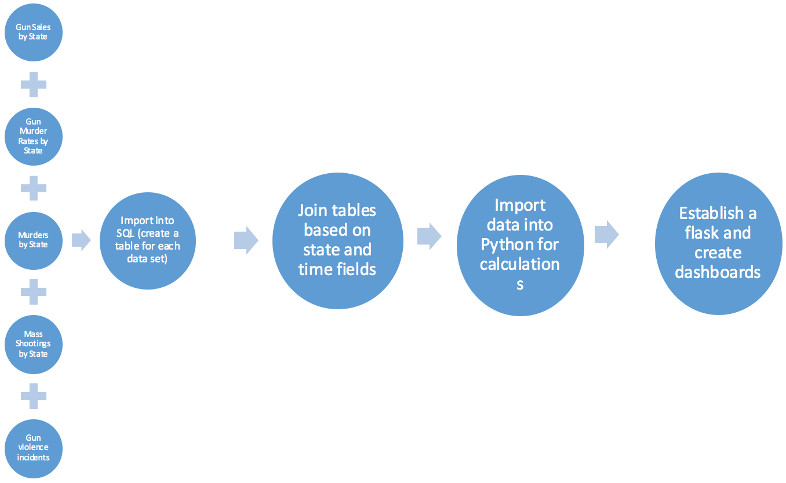

**GitHub Repository**

<https://github.com/HollyV81/Guns-in-the-US.git>

**Project Rough Timeline**

* Day 1:
  + Select topic
  + Find datasets
  + Complete project proposal
  + Sketch website and charts on paper.
* Day 2:
  + Download data and clean CSVs
  + Upload data into SQL database
* Day 3:
  + Inner join databases
  + Establish connection via flask
* Day 4:
  + Create HTML and CSS website skeleton
* Day 5:
  + Data visualization (graphs)
* Day 6:
  + Data visualization (leaflet)

|  |  |  |
| --- | --- | --- |
| **Our Inspiration Graphs** | | |
|  |  |  |
|  |  |
|  |  |  |